GIT CONFLICTS

1. Developer 1 is trying to change the code in a file kk & he commited the changes. It had commited fine with no errors.

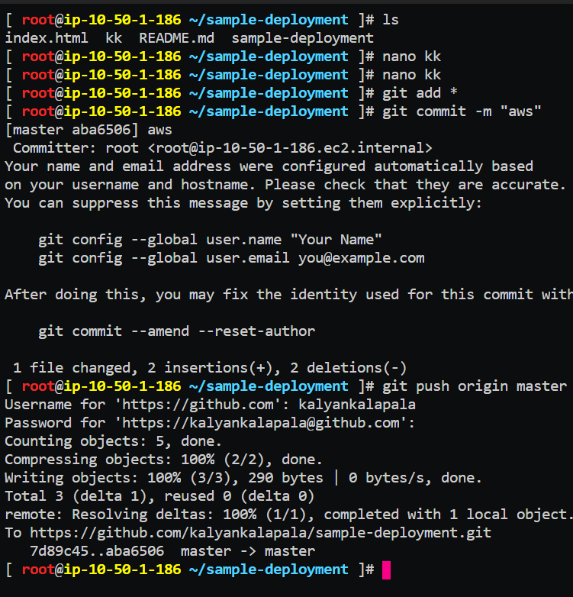

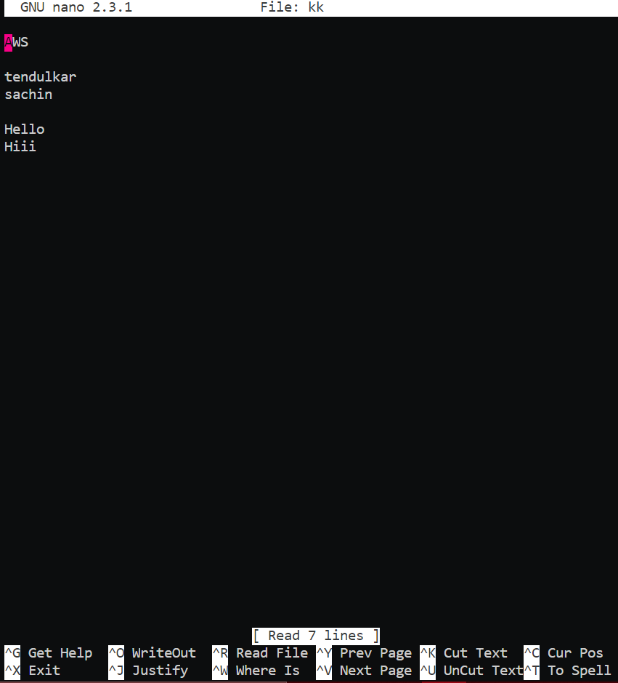

1. Now another developer is trying to change the code in a file kk & he commited the changes. But he had some fetch issues.

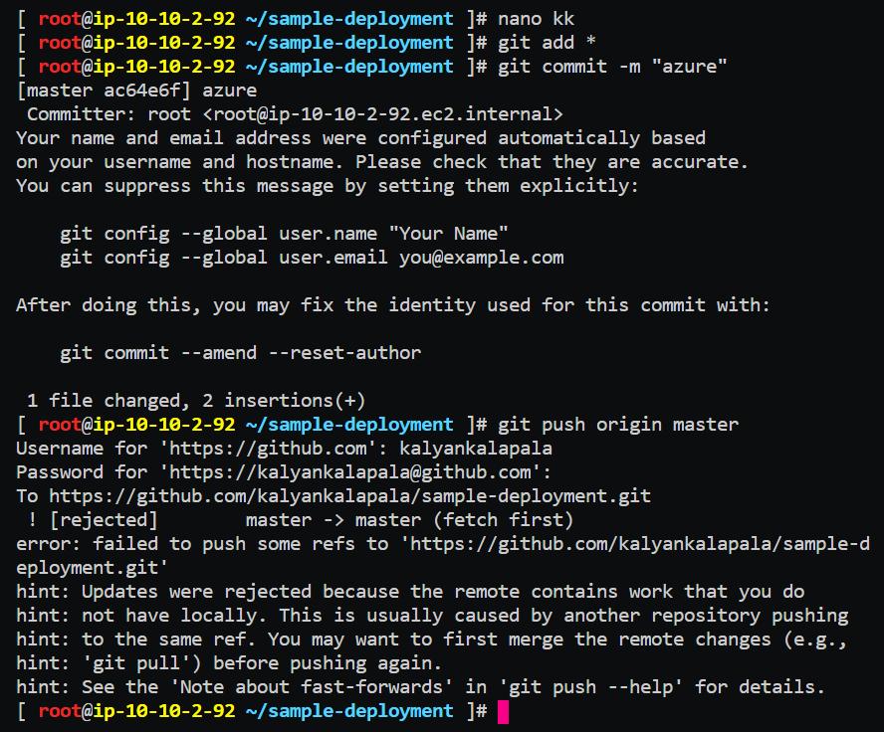

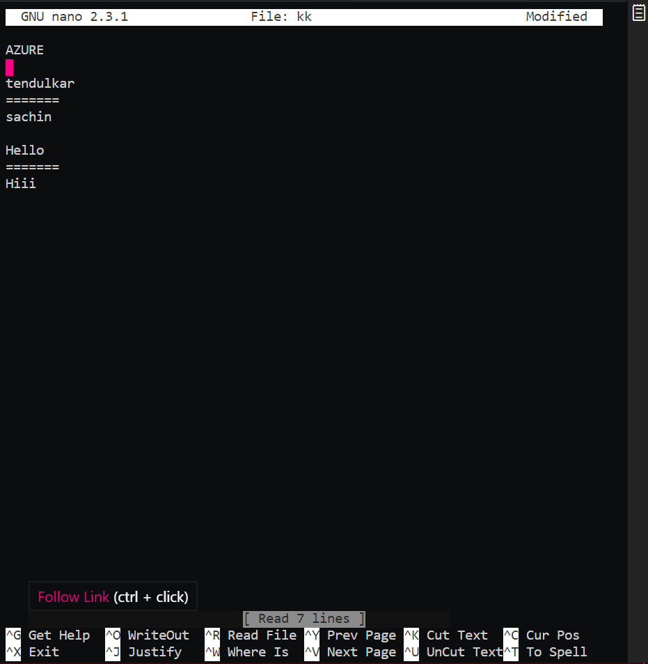

1. Now the developer 2 pulling the changes that were made by the developer 1 & realized that there is some conflict in the file kk.

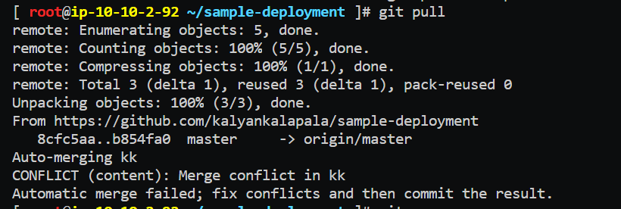

We can see the error in the file and can be resolved by removing those unwanted comments.

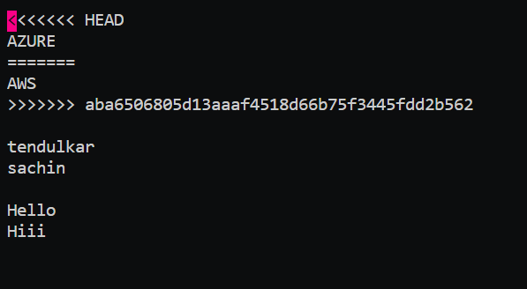

The file will look like this, after removing error comments from the file.

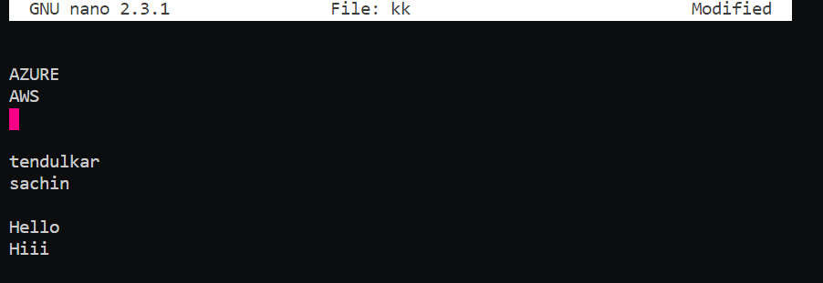

1. Finally add & commit the changes that were made.

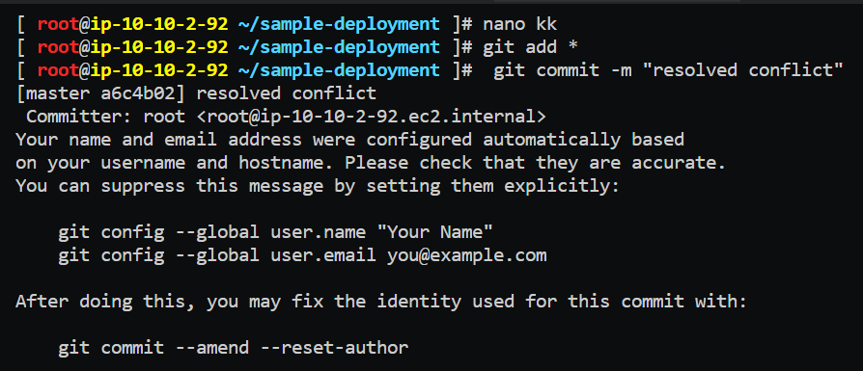

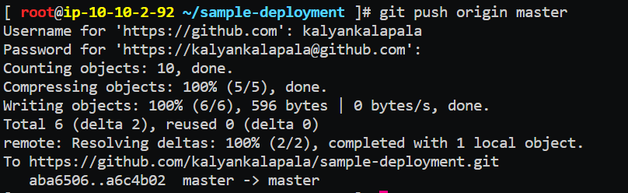

1. Now check the changes that were made

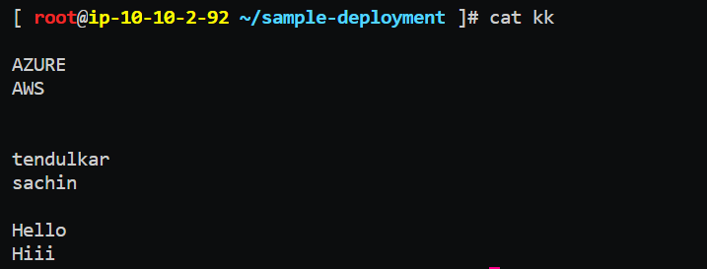

1. Now verify changes were made inside the GITHUB.

